NONG LAM UNIVERSITY  FACULTY OF ENVIRONMENT AND NATURAL RESOURCES | SOCIALIST REPUBLIC OF VIETNAM  Independence - Freedom - Happiness

COURSE DETAILED OUTLINES
UNDERGRADUATE EDUCATION PROGRAM
Major: Environmental Engineering Level: Undergraduate
- General information of the course
- Name in Vietnamese: Năng lượng tái tạo
- Name in English: Renewable Energy
- Module: 212547
- Number of credits: 2
- Conditions for participating in the course
+ Prerequisite: none
+ Prior study:
Department: Environmental Technology
- Duration: 10 weeks
- Semester: 2 (second year)
The course belongs to the knowledge block:
Fundamental □ |  | Fundamental specialized 🗹 |  | Specialized
Mandatory □ | Optional □ | Mandatory □ | Optional 🗹 | Mandatory | Optional
- Teaching language: English Vietnamese 🗹
- Information of lecturer
- Name: Vu Van Quang
- Position, title, degree: Lecturer, M.Sc
- Phone, email: 0983168862, vanquangmt@hcmuaf.edu.vn
- Time and place of work: Office hours, Department: Environmental Technology
- Address: Nong Lam University, quarter 6, Linh Trung ward, Thu Duc district, Ho Chi Minh city, Vietnam
- The main research orientations: Environmental Engineering
- Information about tutors/lecturers who teach together (if any) (full name, phone number, email):

- Course description:
This course provides students with knowledge of renewable energy forms and an understanding of the environmental impacts of exploiting and using renewable energy sources.
- Course goals and Expected Learning Outcomes
Course goals
- After completing the course, students are able to:
Knowledge:
• Understand renewable energy sources and assess the impact of renewable energy sources on the environment during exploitation and use.
• Orientation to use renewable energy forms and their development potential in the future.
Skill:
• Identify renewable energy sources, think creatively to find clean and green energy sources.
• Equip learners with presentation skills, group activities and report writing.
Attitude:
Responsible.
•Respect everyone.

The course contributes to the following Output Standards of the training program according to the following levels:
Module | Subject | Learning outcomes (PLO) dedication degree
212547 | Renewable Energy | 01 | 02 | 03 | 04 | 05 | 06 | 07 | 08 | 09 | 10 | 11 | 12 | 13 | 14 | 15 | 16
 |  | S | S | H | H | S | S | S | S | H | N | S | H | S | S | S | S

Note:
N: none supporting
S: small supporting
H: high supporting
- Course learning outcomes (according to Bloom measurement scale) :
Symbol | Course learning outcomes  Completing this module, students can implement | Symbol
Knowledge
CLO1 | Understanding renewable energy sources | PLO1, PLO2
CLO2 | Assess the impact of renewable energy sources on the environment in the process of exploitation and use | PLO3, PLO4,
CLO3 | Orientation to use renewable energy forms and their development potential in the future | PLO5, PLO6
Skills
CLO4 | Know how to coordinate with team members to solve the requested issues, respecting collective opinions | PLO7, PLO8
CLO5 | Collect the necessary data to carry out the required topics | PLO9, PLO11, PLO12
Attitude and moral qualities
CLO6 | Have a high sense of responsibility and autonomy at work | PLO13, PLO14, PLO15, PLO16
V. Teaching and learning methods
- Teaching methods
- Combine lectures, slides and videos presentation
- Q & A (questions and answers)
- Give teaching materials, homework and assignment
- Learning methods
- E-learning and self-learning (students read the materials and watch video tutorials)
- Students present assigned topics in class and do the discussion
- Students write reports about the assigned topics

- Tasks of students
- Attendance: Students must attend at least 80% of the class period, ask for permission before being absence
- Prepare for the lesson: Students do homework and the assignment at home, prepare the presentation slides and questions to participate the discussions in class
- Attitude: Students actively participate in the discussion, ask questions and answer the questions
- Evaluation and grade scale
- Grade scale: 10
- Evaluation plan and weight
Table 1. Matrix assesses the course learning outcomes of the module (percentage points according to the academic regulations of NLU)
Course learning outcomes | Attendance | Presentation | Final exam (70%)
 | (10%) | (20%)
CLO1 |  | x | x
CLO2 |  | x | x
CLO3 |  | x | x
CLO4 |  | x
CLO5 |  | x | x
CLO6 | x

Table 2. Framework of evaluation criteria (Rubric)
- Class attendance (10 %)

Criteria | Percent (%) |  | Level
 |  | Excellent | Good | Average | Poor
 |  | 7-10 | 7-5 | 5-4 | > 4
Class attendance | 100 | Attend <80% of the class period | Attend 70-80% of the class period | Attend 40-70% of the class period | Attend >40% of the class period
- Topic presentation (30%)
During the learning process, there will be topics reported, each subject has about 5-8 students to perform. Students who report on the topic will receive a maximum of 3 points
Criteria | Percent (%) |  | Level
 |  | Excellent | Good | Average | Poor
 |  | 3 | 2 | 1 | 0
Content | 30 | Fully present the required content on the topic, with additional relevant content contributing to the expansion of knowledge | Full presentation of the required content on the topic | Insufficient presentation of the required content on the topic | Presenting irrelevant content or content that is too sketchy, does not provide the necessary information.
Report form | 20 | The presentation is clear, easy to understand, and creative. Get comments/questions of interest | The presentation is clear and easy to understand. | Presented in a reading form, not generating interest from the audience | The presentation is too sketchy, the audience cannot understand the content
Answer the questions | 30 | Questions are answered fully, clearly, and satisfactorily | Answer 70% of questions. | Answer 25-50% of questions. | Can't answer any questions
Team work | 20 | Show collaboration among team members clearly. There is division of answers and reports among members | There is cooperation among team members but it is not obvious | There is no combination of members, one or more members prepare and report | The report is incomplete and has incorrect content.

- Thi kết thúc môn học (7 điểm)
Exam forms | Multiple-choice
Number of questions | 70
Exam time | 60 min
Score per question

- Overall rating
Score | 10 | 9 | 8 | 7 | 6 | 5 | 4 | 3 | 2 | 1 | 0
General assessment | Completed the course with excellence | Completing the course well | Completing the course quite well | Completing the course with good grades | Completing the course with average grade | Completing the course with fair grade | Completing the course | Not achieved

VIII. Textbooks and references
  - Textbook:
- Nguyễn Thế Bảo, 2017. Năng lượng tái tạo và sự phát triển bền vững. NXB ĐH Quốc Gia TP.HCM.
- Nguyễn Thanh Hào, Nguyễn Huy Bích, 2015. Kỹ thuật Năng lượng tái tạo. NXB ĐH Quốc Gia TP.HCM.
- TS.Trần Văn Bình, TS.Nguyễn Thế Việt, Lê vi.Nguyên Ngọc, 2011. “Phong Điện Nguồn Năng Lượng Tái Tạo Cho Việt Nam”, NXB Lao Động.
- TS. Hoàng Dương Hùng, Năng Lượng Mặt Trời Lý Thuyết và Ứng Dụng, 2010. NXB KH-KT
  - References
[1] Kenedy William.J, “Energy management”, Prentice Hall, Inc 1984.
[2] Janet Ramage. Energy - A Guidebook

IX. Detail content of module:
Week | Content | LLOs | Teaching and learning activities | Evaluation activities | CLOs
1/  CHAPTER 1 | REGENERAL ENERGY OVERVIEW  1.1 Situation of energy use and development orientation in Vietnam  1.2 The concept of renewable energy  1.3 Classification of renewable energy forms  1.4 Potential and current status of RE development in Vietnam | Understand and grasp about renewable energy sources | Slideshow and discussion | Diligence  Final exam | CLO1, CLO3, CLO6
2  THEMATIC | INSTRUCTIONS FOR IMPLEMENTATION OF THE TOPIC | Collect necessary data to carry out the required topic | Slideshow and discussion | Diligence  Final exam | CLO4, CLO5, CLO6
3-4  CHAPTER 2 | THERMAL ENERGY  2.1 Solar energy  2.2 Energy from heat generating processes | Understanding and grasping about thermal energy sources | Slideshow and discussion | Diligence  Final exam | CLO1, CLO2, CLO3, CLO6
5  BC | THEMATIC REPORTS | Present the requested content | Presentation and discussion | Presentation | CLO4, CLO5
6  CHAPTER 3 | ENERGY DYNAMICS  3.1. Wind Energy (Wind Power)  3.2. Flow Energy (Hydroelectricity)  3.3 Ocean Energy | Understanding and grasping about kinetic energy sources | Presentation and discussion | Diligence  Final exam | CLO1, CLO2, CLO3, CLO6
7  BC | THEMATIC REPORTS | Present the requested content | Presentation and discussion | Presentation | CLO4, CLO5
8  CHAPTER 4 | Chapter 4. BIODENCE  4.1 Biomass  4.2 Biofuels  4.3 Biogas | Understanding and grasping about bioenergy sources | Presentation and discussion | Diligence  Final exam | CLO1, CLO2, CLO3, CLO6
9  BC | THEMATIC REPORTS | Present the requested content | Slideshow and discussion | Presentation | CLO4, CLO5
10  OT | REVIEW | Review and synthesize learned knowledge | Slideshow and discussion | Diligence  Final exam | CLO1, CLO2, CLO3, CLO6
X. Hình thức tổ chức dạy học:
Content | Course management (hours) |  |  |  |  | Course management (hours)
 | Theory | Exercise | Discussion | Practice | Self-learning
Chapter 1 | 3 | - | 3 |  | 6
Chapter 2 | 6 | - | 3 |  | 6
Chapter 3 | 3 | - | 3 |  | 6
Chapter 4 | 3 | - | 3 |  | 12
Review | 3
Sum | 18 | - | 12 |  | 30 | 60

XI. The requirements of lecturer for the module:
Study Ethic:
- Students are required to attend all class sessions. In case of not being able to attend, a notice must be given (by email, phone call, text message). However, the number of hours absent may not exceed 20% of the total study time.
- Students who do not complete the tasks in Section V (not participating and reporting on the Topic) will be banned from taking this subject.
Others:
- Classroom, workshop: rooms full of light and ventilation
- Teaching facilities: classrooms have projectors, micro

HCMC, October 1st, 2018
Dean | Head of Dept | Lecturer
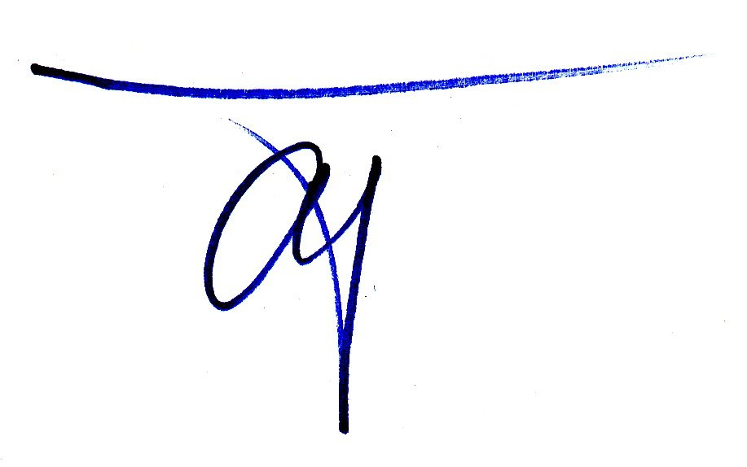  Assoc. Prof. LE QUOC TUAN | 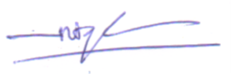  Assoc. Prof. NGUYEN TRI QUANG HUNG | 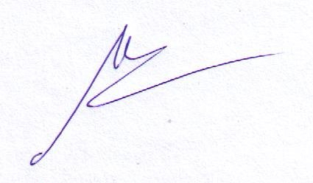  MSc. VU VAN QUANG

